Attorney Generals Department
Green Lease Achievements

Introduction
Work first began on the Attorney Generals Department (AGD) new building project at 3/5 National Circuit, Barton in 2003 with the development of a long-term accommodation strategy for the Department. At that time, in order to comply with policy and meet energy efficiency targets, government agencies were required to document their progress by submitting energy consumption data annually to the then Australian Greenhouse Office within the Department of Environment and Heritage. It is for this reason that the AGD determined that their new building would have the first 'green lease' negotiated by an Australian Government department. They envisioned creating a building that was environmentally efficient, had good amenity for staff, make the best possible use of natural light, and a range of ESD energy efficiencies achieved through sun control, natural ventilation and thermal insulation.
Attorney Generals Building
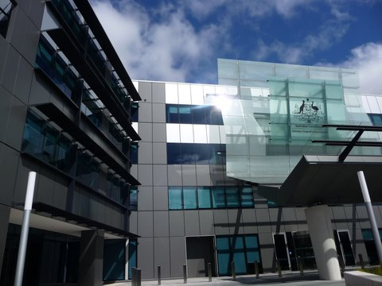
The AGD building fronts 3/5 National Circuit with a striking entry canopy leading into a four storey glazed atrium including interconnecting open access stairs between floors along with interconnecting bridges and glazed lifts. The four levels of office total approximately 20,000m² of net lettable area with 5,000 m² floor plates equally set out in a north and south wing configuration representing the typical office levels. The state-of-the-art integrated fitout features Pavilion-style work points as a first in the ACT, designed to minimise costs for future reconfiguration and ease of construction benefiting the long term tenant requirements.
Practical completion for the project was achieved 23rd March 2009 including the fully integrated fitout, café and crèche facilities for AGD. The building houses 900 staff and is leased via a Gross lease. The building has set new standards for “A” grade accommodation in the ACT in terms of finish, efficiency, fitout and common area solutions and energy usage.

